***Executive Dashboard***

Bringing together diverse data sources into a concise, web-based view for Manufacturing Operations.

***Functionality***



* **Information**: Click on it to take a tour of the page.
* **Date Range**: The default view is all orders in the current fiscal quarter, but you can click to change it.

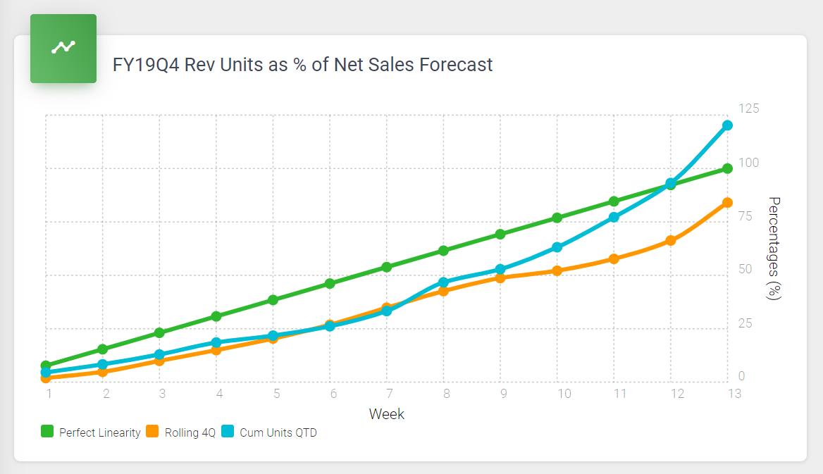

* This chart represents current fiscal quarter revenue orders as a percentage of the Net Sales forecast rolling over the previous four quarters and against perfect linearity.

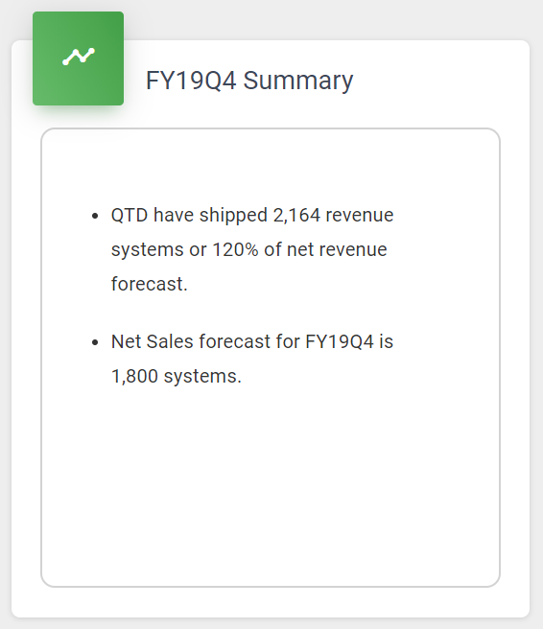

* **Summary**: This box contains text that describes the data being graphed in the chart on the left.

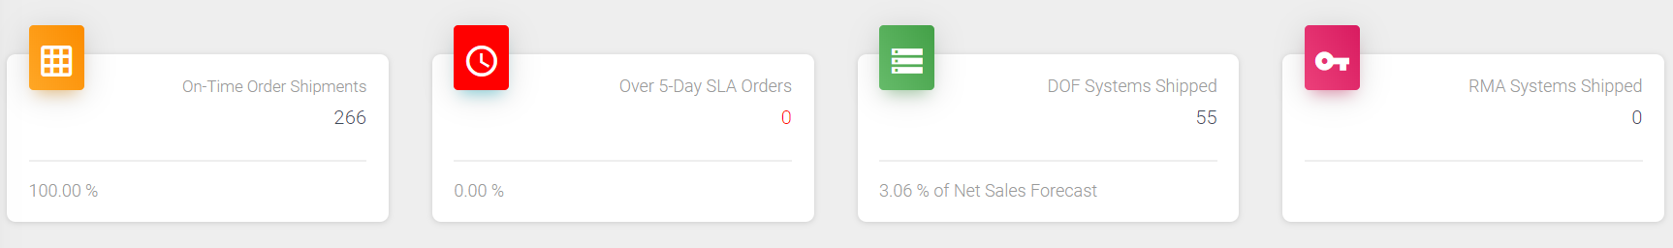

* **On-Time Order Shipments:** This is the number of revenue orders that have been shipped this fiscal quarter within the five-day factory SLA. It includes the percentage of on-time orders compared to total orders shipped.
* **Over 5-day SLA:** This is the number of revenue orders that have been shipped this fiscal quarter that were past the 5-day factory SLA. It includes the percentage of late orders compared to total orders shipped.
* **DOF Systems Shipped:** This is the number of hardware appliances that have been shipped this fiscal quarter. It includes the percentage to Net Sales Forecast.
* **RMA Systems Shipped:** This is the number of RMA appliances that have been shipped this fiscal quarter.

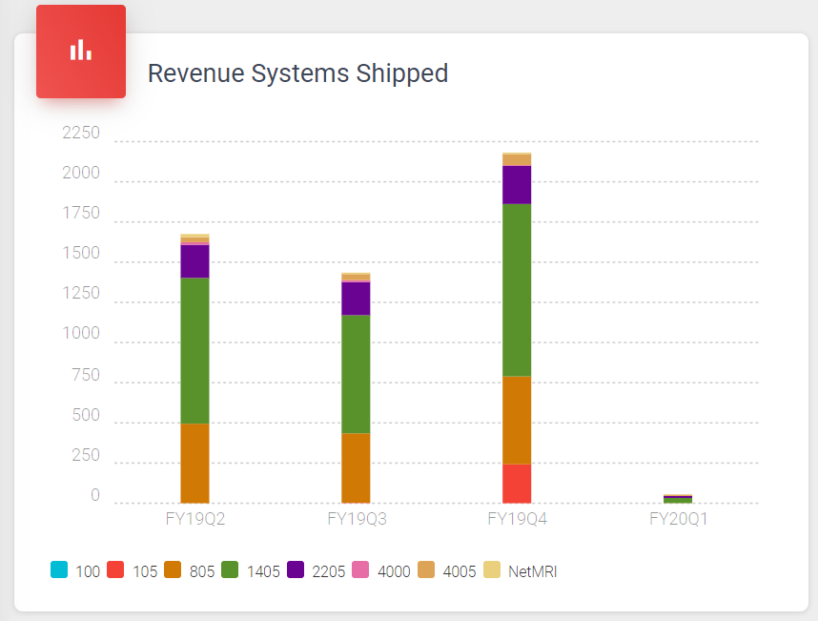

* **Revenue Systems Shipped:** This chart shows the revenue systems shipped by product for the current and previous three fiscal quarters.

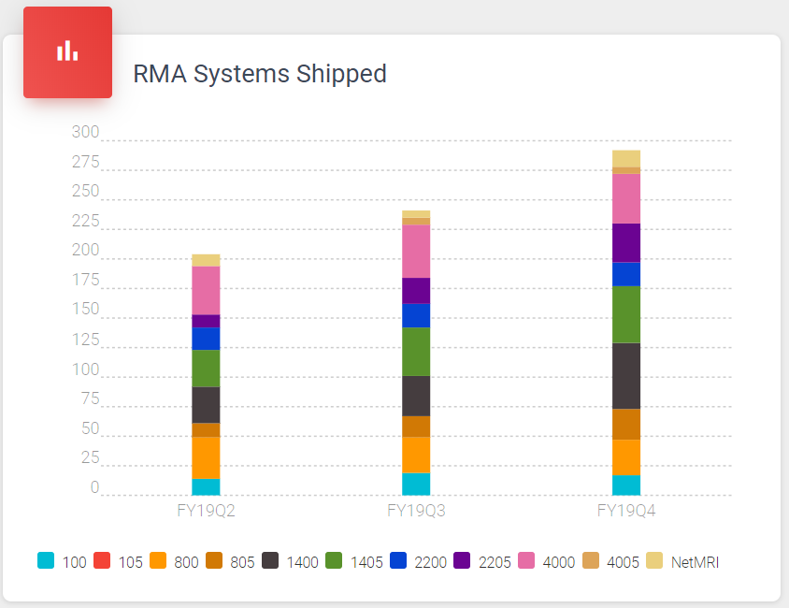

* **RMA Systems Shipped:** This chart shows the RMA systems shipped by product for the current and previous three fiscal quarters.

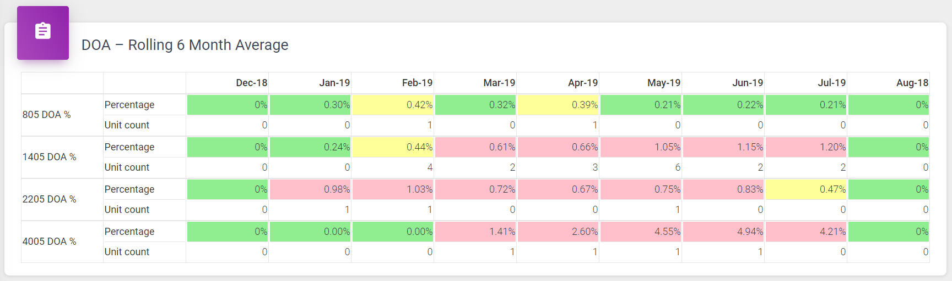

* **DOA- Rolling 6 Month Average:** This chart shows the current and two previous fiscal quarters of DOA (dead on arrival) quality data by product line. Each box is a rolling 6-month average of failure data and includes failure count for that period.

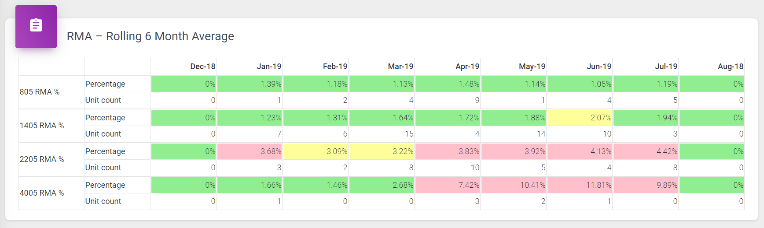

* **RMA- Rolling 6 Month Average:** This chart shows the current and two previous fiscal quarters of RMA quality data by product line. Each box is a rolling 6-month average of RMA failure data and includes failure count for that period.

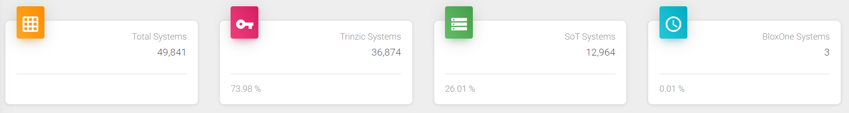

* **Total Systems:** his is the total number of hardware appliances that have shipped. It includes Trinzic, SoT of Trinzic, and BloxOne DDI..
* **Trinzic Systems:** This is the total number of Trinzic hardware appliances shipped. It includes the percentage of total systems shipped.
* **SoT Systems:** This is the total number of SoT hardware appliances shipped. It includes the percentage of total systems shipped.
* **BloxOne Systems:** This is the total number of BloxOne hardware appliances shipped. It includes the percentage of total systems shipped.

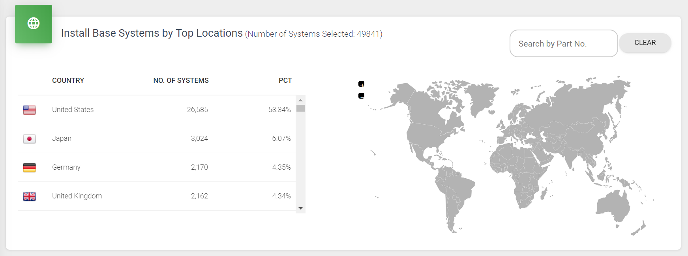

* **Install Base Systems by Top Locations:** This chart displays the current list of hardware appliances covered by an active maintenance contract. You can view summary data by scrolling the table below (by country descending), or you can click on any country on the map below and see the total number of systems active in that country. You can also filter by part number (full or partial) and then view the table or click on a country.
* **Search by part No.:** You can enter any portion of a part number (e.g. 2205, NE-2205, 2205-10GE) to filter the number of appliances that are displayed in the table and country map below.
* **Appliances by Country:** Scroll down the table list of countries to see how many systems, and the percentage to total, reside in those countries. As the part number is filtered this table will automatically adjust.
* **Click the Country:** Mouse hover the country of interest and view the total number of systems in that country matching the filter box above. Click on that country and see a list of all appliances in that' country, including Account Name, Serial Number, Part Number and Install Date.
* **Expand or Contract the Map-View:** Click the plus sign to expand the map view. Click the minus sign to contact the map view.

**List of Tables and Views Used**

|  |  |  |  |
| --- | --- | --- | --- |
| Serial No. | Table Name | View Name | Purpose |
| 1. | OL_LINEARITY_PWK |  | Line Chart |
| 2. |  | v_DASHBOARD_SUMMARY | Count of Order Shipments |
| 3. |  | v_QUALITY_MATRICES | DOA and RMA rolling 6-month average |
| 4. | IB_INSTALL_BASE |  | Systems information on map click. |
| 5. | OL_SYSTEM_SHIPPED_QTR |  | Bar chart |
| 6. |  | v_INSTALL_SUMMARY | No of Systems in each country. |